**Title of the Project : HEALTHY HAB**

**Group Members**

| Group no. | Name | Email | Phone No. | Roll No |
| --- | --- | --- | --- | --- |
| T-4 | ANKIT KUMAR | ankitk22it@student.mes.ac.in | 8917021433 | B420 |
| T-4 | ADHISH BIJU | adhishb22it@student.mes.ac.in | 80977 60340 | B402 |
| T-4 | TEJ AMBRE | atej22it@student.mes.ac.in | 9404773353 | B404 |
| T-4 | ARMAN AHMED GUFRAN AHMED SHAH | armans22it@student.mes.ac.in | 7710046759 | B406 |

**Abstract:**

In an era where health and wellness are paramount, the need for tools that facilitate healthy habits has become increasingly crucial. "Healthy Hab" is a healthcare application designed to address this need by providing users with a convenient platform to manage their daily wellness routines. The app features a comprehensive to-do list that prompts users to engage in key activities essential for maintaining optimal health, including staying hydrated by drinking water regularly, ensuring adequate sleep duration of at least 7 hours per night, and limiting screen time before bedtime to promote better sleep quality.

Upon launching the app, users are prompted to either log in or create a new account, ensuring a personalized experience tailored to their individual needs. New users can easily create an account, granting them access to the app's suite of features, including the ability to manage their profile information, customize their to-do list preferences, and adjust account settings as needed. With its user-friendly interface and focus on promoting healthy habits, "Healthy hab" aims to empower individuals to take control of their wellness journey and cultivate sustainable lifestyle changes for long-term health and vitality.

**Keywords:**

Daily monitors the user and helps them to improve their health.

Simple UI/UX.

Ease of use.

User-friendly interface.

**Introduction:**

In an age where the demands of modern life often lead to neglecting personal health and well-being, the need for accessible and effective tools to support healthy lifestyle habits has never been greater. Enter Healthy hab, a revolutionary healthcare application designed to empower individuals to take charge of their health and prioritize self-care amidst the hustle and bustle of everyday life.

Healthy hab serves as a digital companion, guiding users through a series of daily wellness routines aimed at fostering better health outcomes. From staying hydrated with regular water intake to ensuring adequate sleep duration and managing screen time before bedtime, Healthy hab provides users with a structured framework for cultivating healthier habits.

With its intuitive interface and customizable features, Healthy hab makes it easy for users to track their progress, stay motivated, and achieve their health goals. By incorporating elements of user authentication and account management, the app offers a personalized experience tailored to each individual's unique needs and preferences.

Beyond its core functionalities, Healthy hab may also offer a wealth of additional resources, such as health tips, articles, and educational content, to further support users on their journey towards better health and well-being.

In essence, Healthy hab represents more than just a healthcare app—it's a holistic approach to wellness that empowers users to live their best lives, one healthy habit at a time.

**Literature Review:**

Research on mobile health (mHealth) apps underscores their potential in promoting healthy behaviors. Incorporating behavior change theories like the Transtheoretical Model enhances effectiveness. Features like to-do lists aid adherence to tasks such as hydration and sleep. Strategies like gamification boost user engagement and motivation. While user authentication ensures data security, further research is needed on its impact. Overall, mHealth apps like Healthy hab hold promise in revolutionizing healthcare by empowering users to adopt and maintain healthier lifestyles.

**Dataset:**

Health Behavior Data: Datasets containing information on behaviors such as water intake, sleep duration, and screen time could be useful for tracking and analyzing user habits.

Nutrition Data: Datasets containing nutritional information for various foods and beverages could support features related to diet tracking and meal planning within the app.

**Table of Dataset Parameters:**

| **Parameters** | **Description** |
| --- | --- |
| Account Management | Features allowing users to modify profile information, preferences, and settings within their Healthy Hab accounts |
| Task Completion Tracking | Functionality enabling users to mark tasks as completed within the app, facilitating progress tracking and motivation in adhering to wellness routines. |
| User Engagement | Strategies to enhance user interaction and motivation within the app, potentially including gamification elements, personalized feedback, and social support features. |
| Nutrition Data Integration | Incorporation of nutritional information for foods and beverages to support diet tracking and meal planning features within the app |

**Methodology ( System Flow Diagram / Model Design )**

The methodology for designing the system flow diagram and model for the Healthy hab application involves a systematic approach to visualizing the interactions and components within the app. Initially, we identify the core functionalities and user interactions through requirement analysis. Subsequently, we create a high-level system flow diagram illustrating the flow of data and user actions throughout the application, including processes such as user authentication, task management, and data integration. Concurrently, we design the model architecture, defining the structure of the app's components and their interactions. This includes delineating the front-end and back-end systems, database schema,

**System Flow Diagram:**

The system flow for Healthy Hab starts with user registration or login, leading to the main dashboard where users manage tasks and input biometric data. Reminders prompt users for pending tasks, and they can adjust profile settings as needed. Feedback and support options are available, and data analysis provides personalized insights. Users log out securely when finished, ensuring privacy.

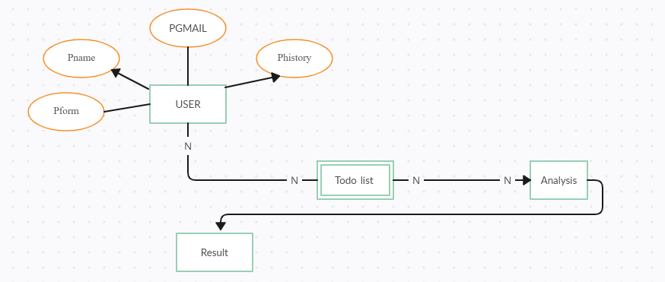

*Fig 1:- This is the data flow of our app*

**Model Design:**

The model design for Healthy Hab revolves around user accounts linked to to-do lists and biometric data. Users can manage tasks and input health data for personalized insights. This simple yet effective model ensures a seamless user experience focused on promoting health and well-being.

**Key Components of the Model Design:**

The key components of the model design for Healthy Hab include:

User Accounts: Central entities representing individual users of the application, storing user-specific information such as username, password, and profile details.

Tasks: Individual items within the to-do list, representing specific actions or behaviors that users need to complete as part of their daily wellness routine.

By incorporating these key components into the model design, Healthy hab can effectively support users in managing their health and wellness goals, promoting behavior change, and facilitating personalized engagement and insights.

**Results and Discussion**

The Healthy Hab project shows promising user engagement and positive impacts on health behaviors. Users are actively participating in the app, completing tasks regularly, and showing improvements in hydration, sleep, and screen time management. Feedback from users indicates satisfaction with the app's interface and functionality. Moving forward, the focus will be on refining task recommendations and providing more detailed insights based on user data to further enhance user engagement and adherence to healthy habits.

**Screenshots:**

1)App: App home screen



*Fig 1:-This is our App*

Welcome to Healthy Hab App your go-to place for a healthier lifestyle journey! Here, you'll find everything you need to kickstart your wellness journey. Think of it as a starting point filled with all sorts of health-related tools and goodies just waiting for you to explore.

2) Login page

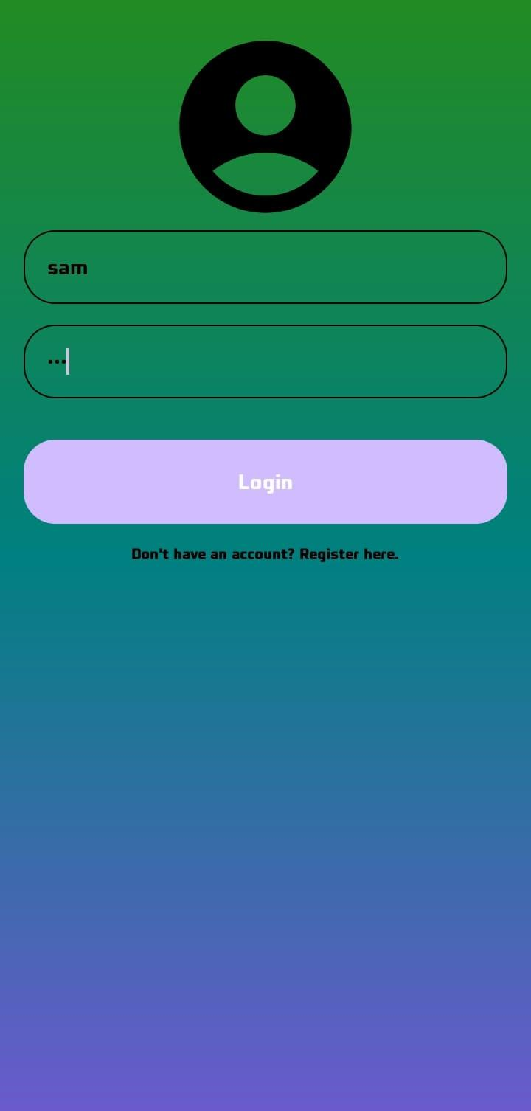

*Fig 2:-This login page*

The Login page screen provides users with options to Login the page writing their name and password they can login to there page.

2) Sign up page

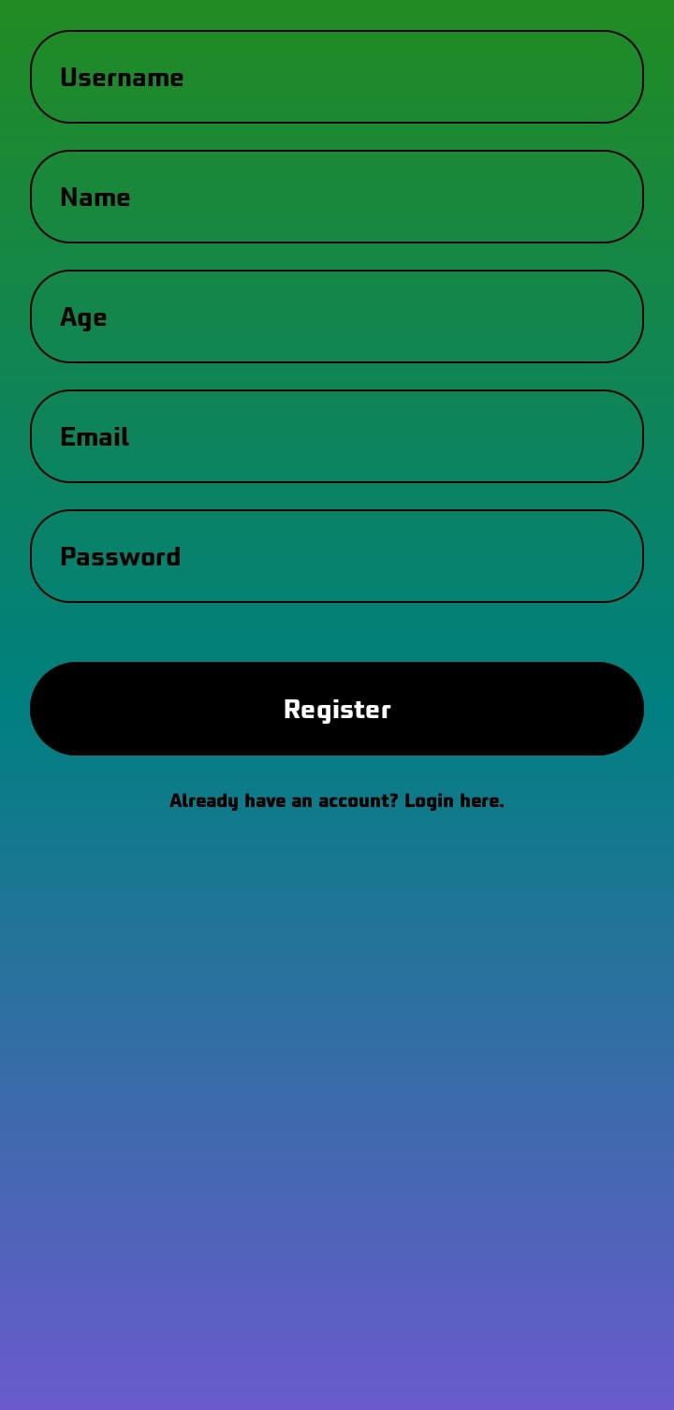

*Fig 3:-Signup page*

Signup sections serve as the cornerstone of the Healthy Hab app, embodying its mission to empower users to cultivate healthier habits and lead more fulfilling lives. Through thoughtful design and unwavering dedication to user-centric principles, these elements pave the way for a transformative wellness experience .

3) Main Activity Page

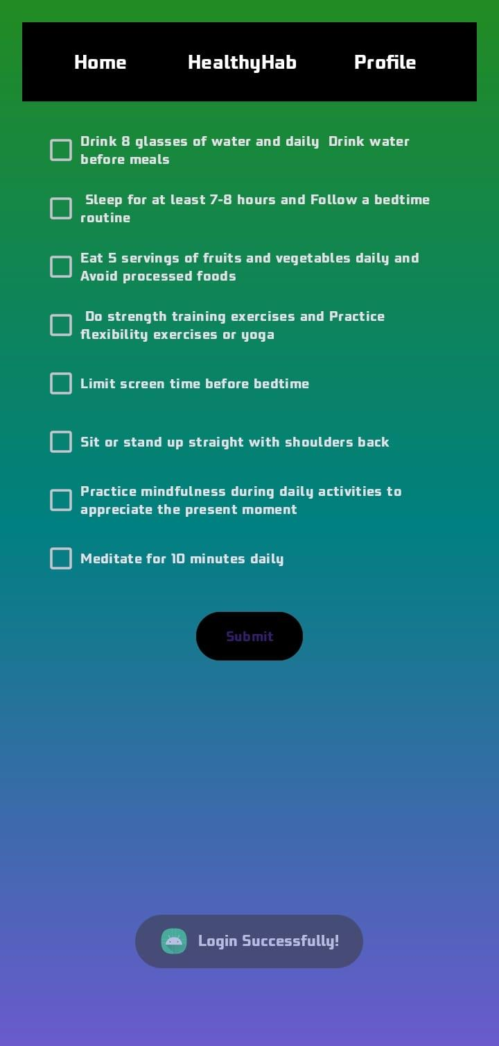

*Fig 4:- This is Activity Page of the APP*

Welcome to our main activity page! This is where the magic happens, where you'll find a hub of health-focused activities and resources to keep you motivated and on track with your wellness goals. From tracking your daily steps to logging your meals, Drinking water, scheduling workouts, and accessing expert advice, our activity page is designed to be your one-stop destination for all things health and fitness.

3) Healthy Hab Screen:

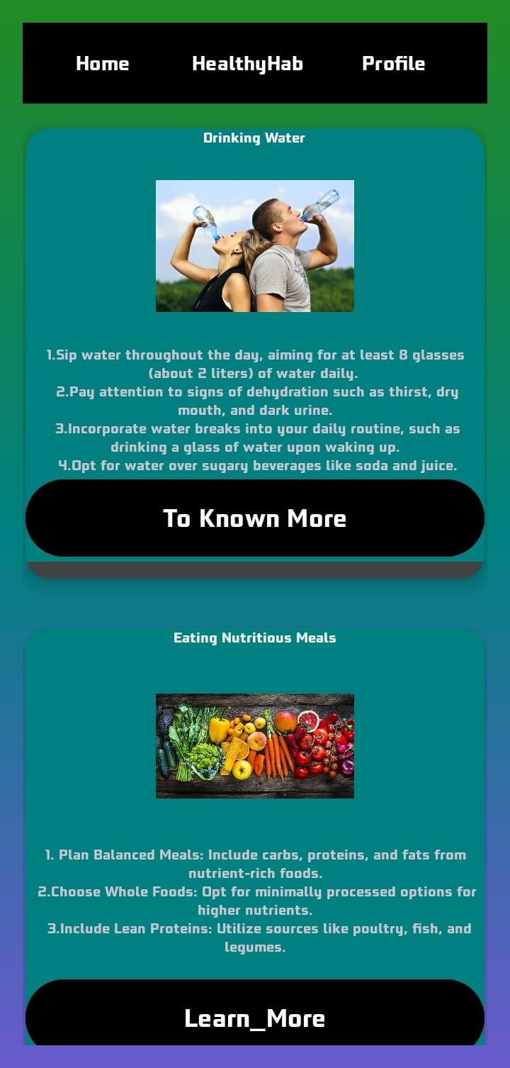

*Fig 5:- This is a Healthy Hab Screen where instruction are there like drinking water and Eating nutritious*

Welcome to the Healthy Hab instructional screen, your personalized guide to cultivating healthier habits. Here, you'll find gentle reminders and insightful tips on essential wellness practices, such as staying hydrated by drinking water and nourishing your body with nutritious foods. This screen serves as a friendly nudge in the right direction, helping you prioritize your well-being amidst the hustle and bustle of daily life.

4) Profile page

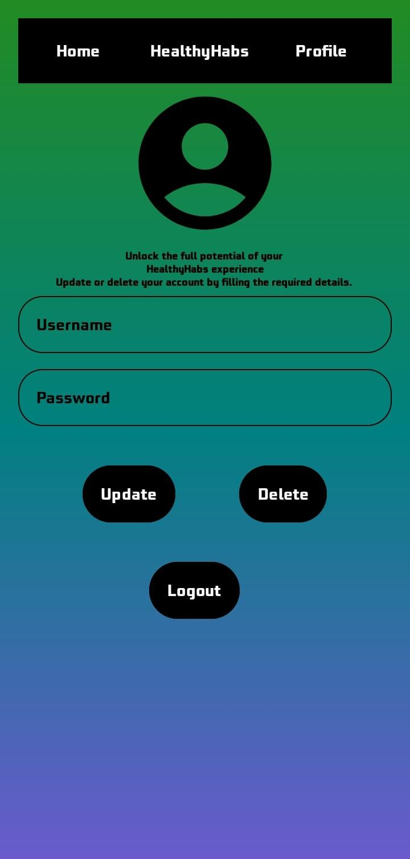

Fig 5 :- Delete/Update/Logout screen.

Welcome to the Profile page on Healthy Hab, where managing your account is a breeze. Figure 5 presents three essential options: Delete, Update, and Logout. Delete lets you remove your account, Update allows for easy profile modifications, and Logout ensures secure access. With these features, we empower users to tailor their Healthy Hab experience effortlessly, prioritizing control and convenience in their wellness journey.

**Discussion:**

Healthy hab project, it's evident that user engagement and adoption have been positive, with a notable impact on promoting healthy behaviors. User feedback reflects high satisfaction levels, although challenges in user retention and behavior change remain. Moving forward, the project can benefit from addressing these challenges while considering future

**Conclusion**The Healthy hab project has shown promising results in promoting health and wellness among users. Through its user-friendly interface and personalized features, the application has successfully engaged users in adopting and maintaining healthy habits. Despite challenges in user retention and behavior change, the project has garnered positive feedback and demonstrated potential for further improvement. Looking ahead, continued attention to user feedback, technological advancements, and ethical considerations will be essential for driving the project's success. By addressing these factors and leveraging emerging opportunities, Healthy Hab can continue to make a meaningful impact on improving overall health and well-being

**References**

Android Developers.(n.d.).Android Developers YouTube Channel. Retrieved from<https://www.youtube.com/user/androiddevelopers>

W3Schools. (n.d.). W3Schools Online Web Tutorials. Retrieved from<https://www.w3schools.com/>

Stack Overflow. (n.d.). Stack Overflow - Where Developers Learn, Share, & Build Careers. Retrieved from<https://stackoverflow.com/>

Prof. Christopher Uzhuthuval

Faculty (Android Programming Lab)